A1. Security concepts on campus
- CCTV Camera (Surveillance)
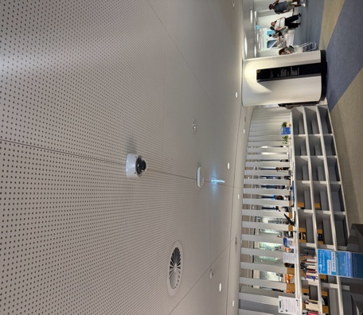

Location: Inside Reid Library
Security Concept: Surveillance / Monitoring
Explanation:
CCTV cameras are used to monitor activities inside campus buildings. They help security staff observe what is happening in real time and record footage that can be used as evidence if theft, vandalism, or other incidents occur. Cameras also discourage people from committing crimes because they know they are being recorded.
- Secure Building Entrance / Access Control
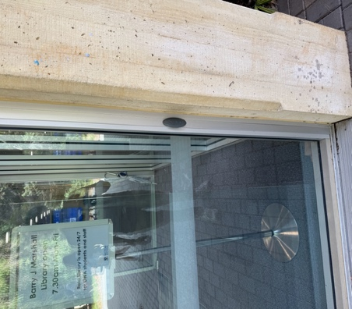

Location: Outside Berry J Marshall Library
Security Concept: Access Control
Explanation:
Access control systems regulate who can enter buildings or restricted areas. Many university buildings use key-card or automated doors to allow only authorized students and staff to enter. This helps prevent unauthorized access and improves campus safety.
- CCTV Warning Sign (Security Awareness / Deterrence)
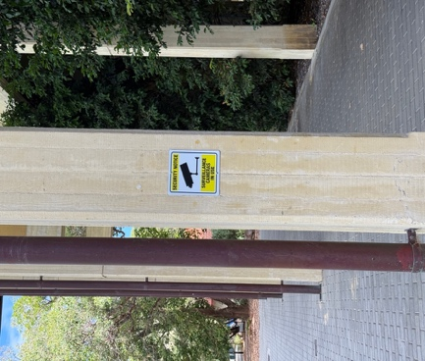

Location: Nere to Berry J Marshall library
Security Concept: Deterrence and Awareness
Explanation:
Security signs inform people that the area is monitored by cameras. This discourages illegal activities such as theft or vandalism because people know they are being watched. These signs also increase awareness about security measures on campus.

- Campus Emergency Help Point
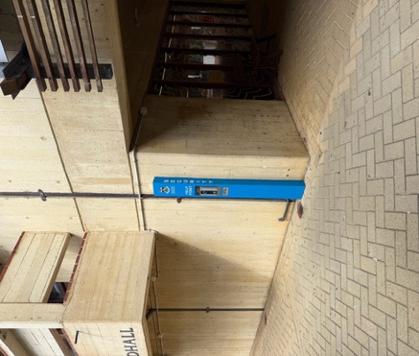

Location: Opposite to Student Central
Security Concept: Emergency Communication
Explanation:
Emergency help points allow students and staff to quickly contact campus security if they feel unsafe or need assistance. By pressing the button, users can communicate directly with security staff who can provide help or send emergency services if needed.
- Fire Extinguisher (Emergency Safety)
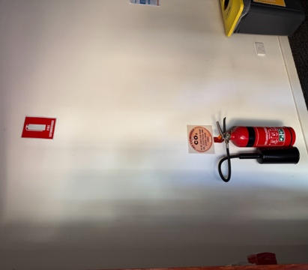

Location: Psychology North Block
Security Concept: Fire Safety / Emergency Response
Explanation:
Fire extinguishers are important safety equipment used to stop small fires before they spread. They help protect students, staff, and property during emergencies. Having them placed around campus buildings allows quick action in case of fire.

